Provider Lookup Job Aid
The purpose of this Provider Lookup Job Aid is to help you accurately look up in network providers for the plans you are selling. Provider relationships are very important to consumers and network status is part of their decision making process. There are many different types of providers and networks can be complex. This job aid will provide you with all the knowledge you need to set correct expectations with consumers.

Overview 3
Frequently Asked Questions 3
Best Practices 5
General Navigation 6
Accessing Online Provider Search Tools 6
Data Accuracy 8
Changing the Search Type 9
Type of Doctor Dropdown Entries 10
Printing a custom PDF 11
Medical Providers for Medicare Advantage Plans 11
Searching for a PCP or other Physician 11
Search Results (Physician) 15
Searching for a facility 16
Search Results (Facility) 19
Searching for a Medical Group 20
Search Results (Medical Group/Network) 23
Medical Providers for Dual Special Needs Plans 24
Searching for DSNP providers 24
Ancillary Benefits 24
National Ancillary Benefits 24
Vision 27
Dental 28
Hearing 33
Behavioral Health 35

Overview

Acronym References

Common acronyms and abbreviations that may be used in this job aid are listed below:

Acronym | Description
CMS | Centers for Medicare & Medicaid Services
DSNP | Dual Special Need Plan
FFS | Fee-for-Service
INN | In-network
MA | Medicare Advantage
MA-PD | Medicare Advantage Prescription Drug
NPPO | National Preferred Provider Organization
OON | Out-of-Network
PA | Prior Authorization
PCP | Primary Care Physician
PDP | Prescription Drug Plan
PFFS | Private Fee for Service
VAIS | Value Added Information and Services

Frequently Asked Questions

I need a printed copy of the provider directory to carry with me. How can I get one that is accurate?
Custom printed directories can be created using the Online Provider Lookup tool. The tool is updated weekly so agents should update directories weekly prior to appointments and/or Marketing Sales Events or contact the PHD. For more information see Printing a Custom PDF

The lookup tool lists two different PCP IDs for the same provider. Which one should I put on the application? If multiple PCP IDs exist for the same provider at the same address, either one can be placed on the application. Exception: Provider Specific Plans (PSP) – If your market includes these types of plans, reach out to your local leadership team to for any additional requirements/information necessary to perform a successful provider search.

How can I ensure I am providing a consumer with the most accurate information possible?
UnitedHealthcare is an industry leader in data accuracy, but it is important agents understand which resources will provide the most accurate information. For more information see Data Accuracy

The consumer doesn’t have internet access, how can I look up the consumer’s providers?
Print a custom PDF of the provider directory prior to appointments and/or Marketing Sales Events or contact the PHD. Avoid using full printed provider directories as they are a higher risk for outdated/inaccurate information especially when the consumer expresses interest in particular physicians or facilities.

Why is an out-of-network provider refusing to see a consumer, when the consumer’s plan has out-of-network benefits (PPO or POS) or non-network benefits (PFFS)?
For PPO and POS plans, ensure the consumer understands that although they can see physicians outside of the network the physician is not contractually obligated to see them. The physician may not agree to accept the consumer as a patient.

For PFFS plans, ensure the consumer understands that they must see Medicare-eligible physicians who agree to accept the plan’s terms and conditions of payment and agree to treat the member on a per-visit basis.

What do I do if I find a data inaccuracy within the directory?
If you find data inaccuracy within the directory, report this information to your local leadership for follow-up.

Who receives a Primary Care Physician assignment?
Some plans require the member to have a designated Primary Care Physician (PCP) and it will be noted on their member ID card. If the enrollment application contains Name and ID fields for a PCP, then a PCP is required and both fields must be populated. Otherwise, if there is not a PCP field on the enrollment application, PCP does not need to be designated.

What are the requirements for an accurate Primary Care Physician assignment?
The Name and ID fields on the enrollment application must be populated exactly as the information appears in the Online Directory. For more information see Search Results (Physician)

There are plans in my market that are designed to meet very specific consumer needs. Is there additional information I need to successfully look up providers for these plans?
Yes, in select areas of the country there are provider specific plans (PSP) and/or plans that have a very narrow network. Examples: Southern California, Mosaic, etc. If your market includes these types of plans, reach out to your local leadership team for any additional requirements/information necessary to perform a successful provider search.
Return to Table of Contents

Best Practices

The items below are best practices agents should use when looking up, selecting, and communicating information about providers:

  - Use the most accurate provider look-up source
  - It is not recommended to use a physician office as a source of truth or any web searches not associated with a UnitedHealthcare tool (exception: Vision)
  - Printed provider directories are a higher risk for outdated/inaccurate information
- Ask consumers what types of doctors and facilities are important to them, including specialists they only see occasionally
  - Look up all physicians (PCP and specialist) and facilities when meeting with a consumer not just PCP
- Confirm that the provider or facility is in-network for the plan in which the consumer is enrolling
  - Do not make assumptions about the network. A physician can be in the network for one plan, multiple plans, or all plans in a market. See Search Results (Physician) for more information
  - Look up each provider separately to verify network status. Just because one provider in a group, practice, or facility is in-network does not mean all physicians associated with the same group, practice, or facility are also in-network. See Search Results (Medical Group/Network) for more information.
- Set expectations to avoid surprises
  - If the network is narrow or the plan requires referrals to see a specialist, make sure that is communicated to the consumer.
  - Help the consumer understand the value of the PCP and work with them to find one in the UHC network, if they don’t currently have one. PCP auto-assignment will occur, if you don’t do this at time of enrollment
  - Although it’s not common, ensure the consumer understands that networks/contracts can change throughout the year. If a provider contract is terminated consumers can contact customer service to change providers.
  - Consumers must understand networks/contracts can change throughout the year. In the event their provider(s) is/are no longer contracted with UnitedHealthcare, they can contact customer service or their agent to select a new provider. Consumers must understand they are enrolling for a full year.
    - If a consumer is concerned or has doubts about the network status of a provider they can call customer service, their agent, or lookup the physician on myuhc.com to confirm network status

Return to Table of Contents

General Navigation

Accessing Online Provider Search Tools

- From the United Distribution Portal (UDP) home page, click on the Product Information & Materials tab

- Click on the Provider Search link located under Product Information>Medicare Advantage

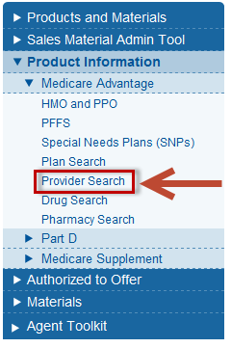

- Select the provider search link that best meets your needs. There are several links included depending on whether you are searching for medical or ancillary providers, if you are searching for providers related to acquired entity plans (Care Improvement Plus, Medica, Preferred Care) or if you are searching for providers in a Dual SNP network.
- Click on the link labeled Click here to launch Provider Search to search for MA medical providers

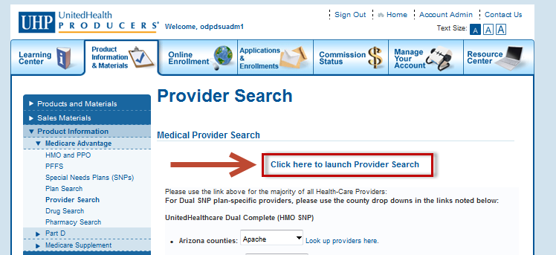

Return to Table of Contents

Data Accuracy

Using outdated provider data can lead to setting incorrect expectations with the consumer regarding in-network status or to provider auto assignment. Incorrect information can result in:
- Consumer complaints
- Consumer dissatisfaction especially if a claim is processed correctly as outof-network when an agent told the consumer that the provider was in-network
- PCP auto assignment

In addition, auto assignment of a PCP has the potential to:
- Cause member dissatisfaction
- Delay member access to services due to inaccurate PCP assignment
- Lower Star Rating for the plan
- Lead to negative auto assignment for the writing agent

Use the table below to compare the various resources available to confirm provider network status.

Resource | Comments | Update Frequency
Online Provider Search Tool | Access this resource through the UDP or the relevant consumer site. It is the most up-to-date and accurate source for provider information and should be used whenever possible. | Weekly (Every Thursday)  Note: Providers and facilities that are terminating their contract are removed 30 days prior to their termination date.
Producer Help Desk (PHD) | Contact the PHD during the PHD’s hours of operation, when you do not have internet access and need access to the most up-to-date provider network information. The PHD can access the Online Provider Search Tool. | N/A
Provider Directory Hard Copy | This resource is attained through local market leader/management. Any changes that occur after July will not be reflected in this directory, unless there is a significant change in the network. Even if there is a significant change, a reprint is not guaranteed. Using this resource presents a high risk for outdated provider information | Annually prior to OEP (based on July network status)
Online Printable Directory | The online printable directory is an electronic version of the printed directory available for download on the UDP. Using this resource presents high risk for outdated provider information. | Annually prior to OEP (based on July network status)

Return to Table of Contents

Changing the Search Type

Use the START OVER button to return to the initial search screen. After clicking this option, a new “Find a Doctor, Facility, or Medical/Group/Network” screen will open allowing you to change your search type using the radio buttons.

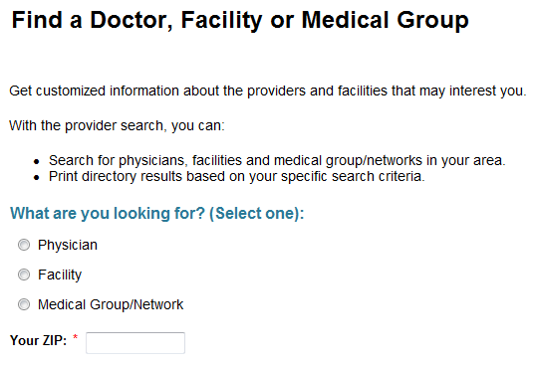

Return to Table of Contents

Navigating Search Results

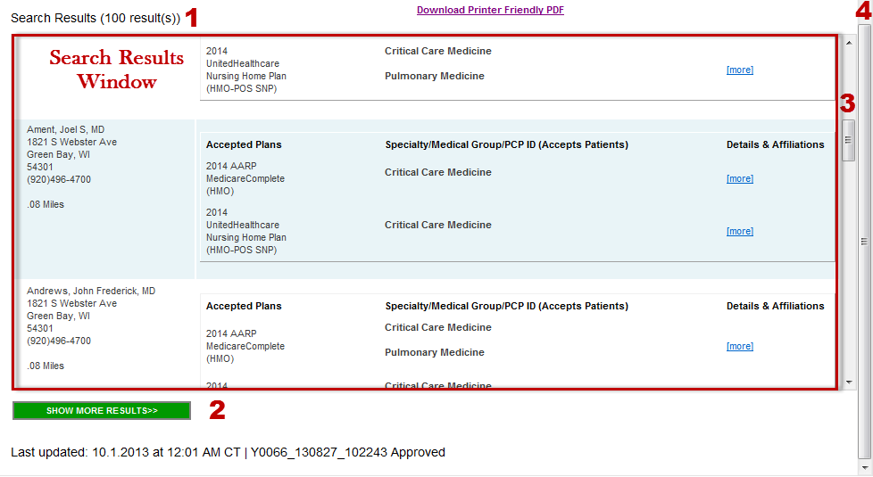
The total number of search results (1) matching the search criteria will be displayed above the Search Results Window

The Search Results Window will display the first ten records matching the search criteria. Use the inside scroll bar (3) to scroll through the matching records. If there are more than ten results, use the outside scroll bar (4) to scroll to the bottom of the page and access the SHOW MORE RESULTS button (2). When the SHOW MORE RESULTS button (2) is clicked, the next ten records will display under the initial ten results. Continue to use the inside scroll bar (3) to scroll through the matching records. Repeat this process to add an additional ten records up to the maximum of 100

Return to Table of Contents

Type of Doctor Dropdown Entries

The Type of Doctor dropdown list contains entries for both physicians and facilities, but will only return results based on the radio button selected (physician, facility, medical group/network) on the initial “What are you looking for” screen. For example, if you choose Physician on the initial search screen and then select Hospital from the Type of Doctor dropdown list, no results will be returned. Use the START OVER button to change the search type.

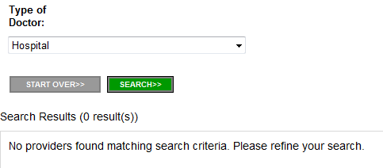
Return to Table of Contents

Printing a custom PDF

Click on the Download Printer Friendly PDF button to create a printable version of the search results. Note: Only the records showing in the Search Results Window will be added to the PDF. See Navigating Search Results for more information. Note: searching is currently limited to 100 results. You can limit results by geography or type of physician.

Return to Table of Contents

Medical Providers for Medicare Advantage Plans

Searching for a PCP or other Physician

- Select the Physician radio button
- Enter a zip code in the Your ZIP field (after entering the zip code, a continue button will appear )
- Click CONTINUE to move to the next screen

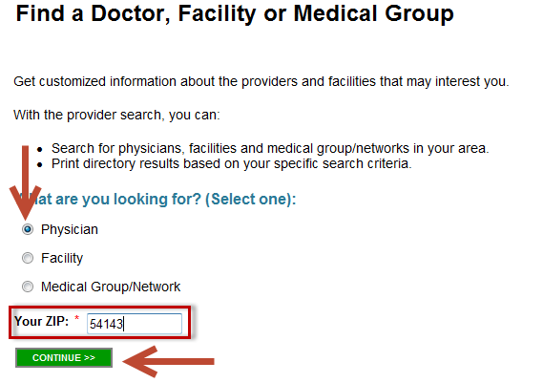
- Select a plan from the Plan dropdown list to ensure you are searching for providers that are in-network for the plan you are selling, OR review “accepted plans” in the search results to verify the provider’s status if you choose “No Preference”
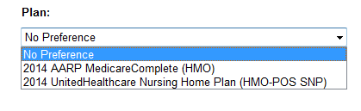
- Add any additional information to narrow search results

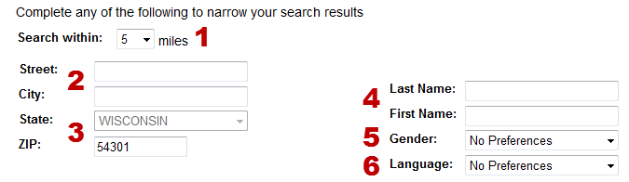

1. Search within | Allows user to enter a mileage radius
2. Street/City | If entering a Street Address, a City must also be specified
3. State/Zip | This is pre-populated based on the zip code entered on the previous screen
4. Last Name/First Name | If searching by name, both Last Name and First Name fields must contain at least two letters
5. Gender | Allows user to search for providers by a specific gender
6. Language | Allows user to search for providers speaking specific languages in addition to English

- Choose the type of doctor

For a PCP, choose Show Only Primary Care Physicians located at the top of the dropdown list
For a Specialist, choose the appropriate specialty from the alphabetized list
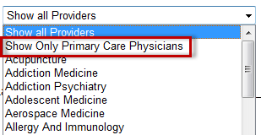
- Click the SEARCH button

- The results will appear below the search criteria fields
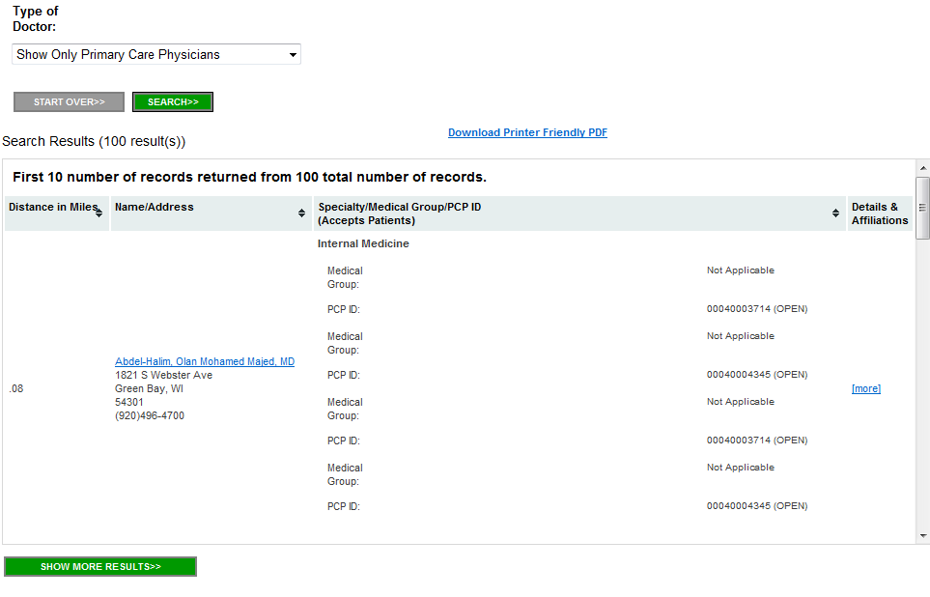
Return to Table of Contents

Search Results (Physician)

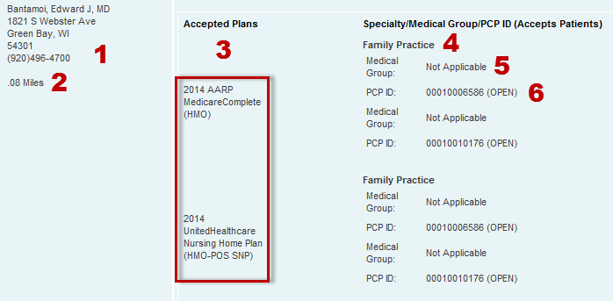
1 | Provider Name, Address, and Phone Number
2 | Distance from address or zip code used to for the search
3 | Plans accepted by the provider. If searching using a specific plan only that plan will be displayed
4 | Provider Specialty
5 | Medical Group Affiliation (if applicable)
6 | Provider ID Number and Patient Status - Only populated for PCPs  Status Descriptions:
 | (OPEN) | Physician is accepting any UnitedHealthcare enrollees.  Auto-assignment only occurs if there was an error when filling the application out and the PCP information was inaccurate or excluded.
 | (EXISTING) | Physician is only accepting enrollees who are current patients. It is important to check the “existing patient” box on the application.  Auto-assignment of a new physician will occur if the existing patient box is not checked or if there is incorrect PCP information on the application.
 | (CLOSED)  DO NOT SELECT | Physician is not accepting any UnitedHealthcare enrollees, new or existing patients. Consumers must pick a new physician when filling out the application.  Auto-assignment will occur with the selection of a closed panel PCP on the application.

Return to Table of Contents

Searching for a facility

- Select the Facility radio button
- Enter a zip code in the Your ZIP field (after entering the zip code, a continue button will appear )
- Click CONTINUE to move to the next screen

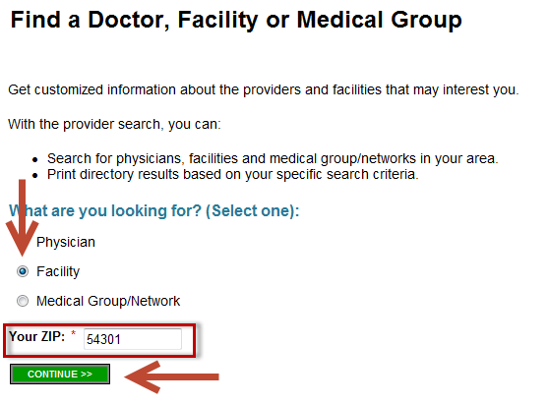
- If prompted, select the appropriate county and click NEXT
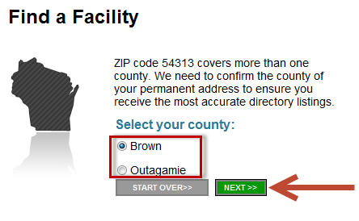

- Select a plan from the Plan dropdown list to ensure you are searching for providers that are in-network for the plan you are selling, OR review “accepted plans” in the search results to verify the provider’s status if you choose “No Preference”
- Add any additional information to narrow search results
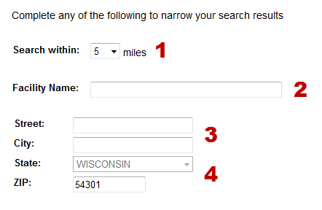
1. Search within | Allows user to enter a mileage radius
2. Facility Name | Search by a specific facility name (can be full or partial name, but must contain at least two characters)
3. Street/City | If entering a Street Address, a City must also be specified
4. State/Zip | This is pre-populated based on the zip code entered on the previous screen

- Choose the facility type from the dropdown
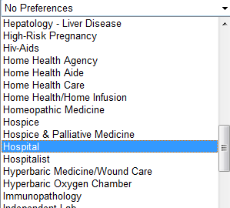
- Click the SEARCH button

- The results will appear below the search criteria fields
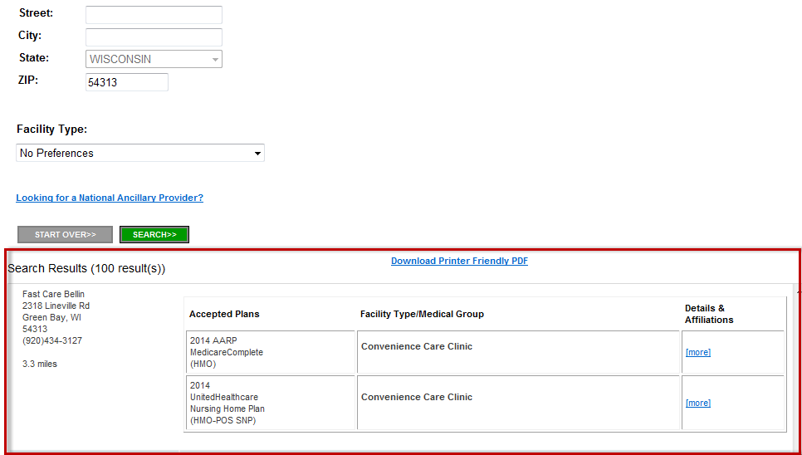
Return to Table of Contents

Search Results (Facility)

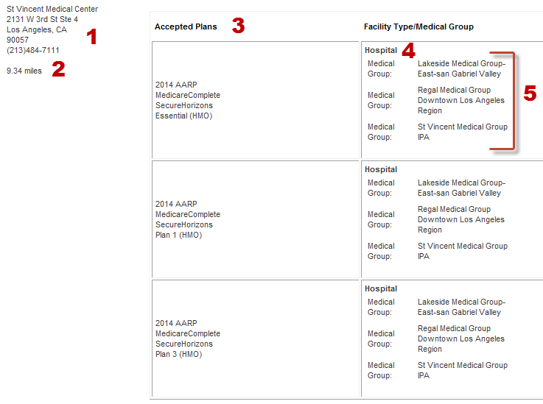

1 | Facility Name, Address, and Phone Number
2 | Distance from consumer address to facility location
3 | Plans accepted by the facility
4 | Type of facility
5 | Medical Group Affiliation

Return to Table of Contents

Searching for a Medical Group

- Select the Medical Group/Network radio button
- Enter a zip code in the Your ZIP field (after entering the zip code, a continue button will appear )
- Click CONTINUE to move to the next screen

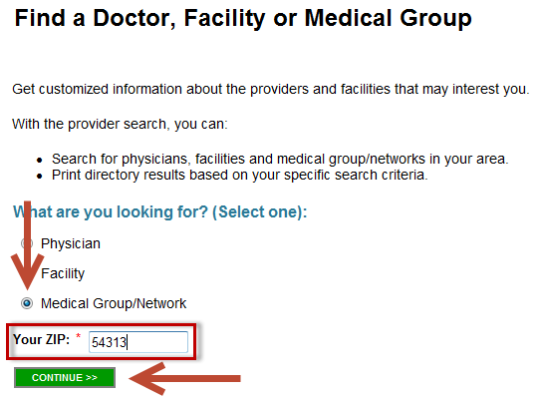

- If prompted, select the appropriate county and click NEXT

- Select a plan from the Plan dropdown list to ensure you are searching for providers that are in-network for the plan you are selling, OR review “accepted plans” in the search results to verify the provider’s status if you choose “No Preference”. If left as default setting, "No Preference", provider search results will be listed for all available plans in the market.
- Add any additional information to narrow search results
1. Search within | Allows user to enter a mileage radius
2. Medical Group/Network Name | Search by a specific Medical Group or Network name (can be full or partial name, but must contain at least two characters)

- Click the SEARCH button

- The results will appear below the search criteria fields

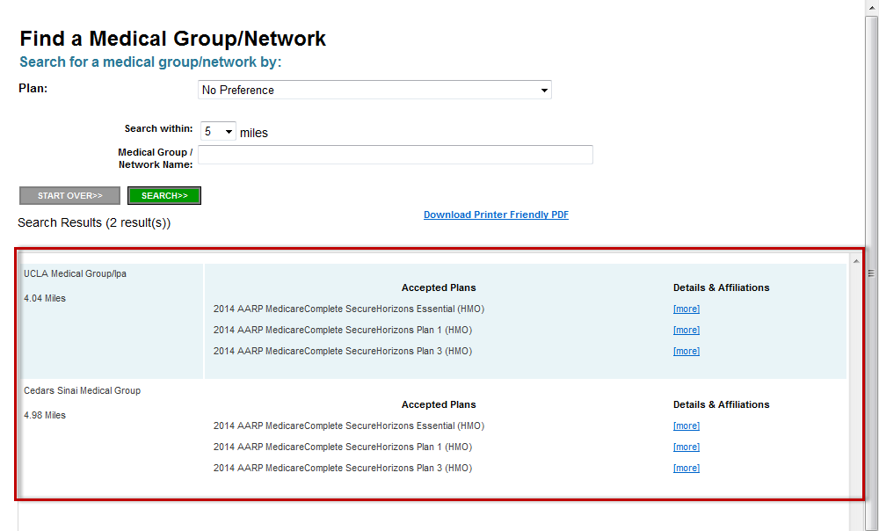

Return to Table of Contents

Search Results (Medical Group/Network)

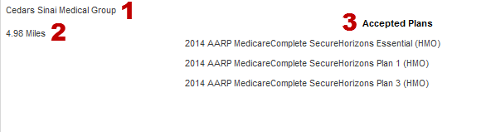
1 | Medical group/Network Name, Address, and Phone Number
2 | Distance from consumer address to medical group/network location (this could be an office or a facility)
3 | Plans accepted by the medical group/network

Return to Table of Contents

Medical Providers for Dual Special Needs Plans (DSNP)

Searching for DSNP providers

Certain counties in Arizona, Michigan, New Jersey, Pennsylvania, Tennessee and Wisconsin have specific provider search tools for DSNP plans. To look up providers in one of the counties choose the county from the dropdown and click on the Look up providers here link

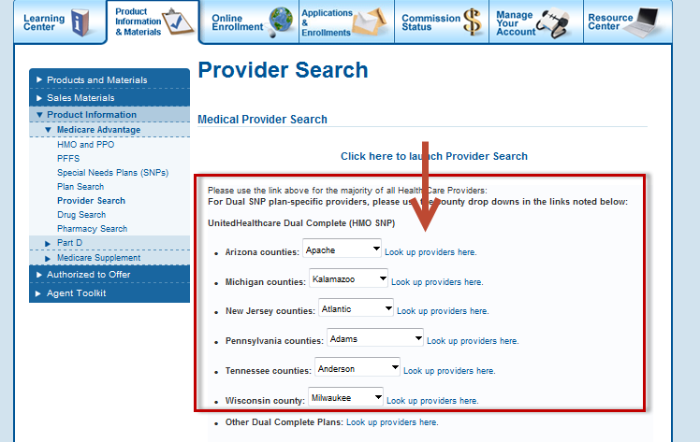

Ancillary Benefits

National Ancillary Benefits
- Select the Facility radio button
- Enter a zip code in the Your ZIP field (after entering the zip code, a continue button will appear )
- Click CONTINUE to move to the next screen

- If prompted, select the appropriate county and click NEXT

- On the Facility Search screen, click on the Looking for a National Ancillary Provider? link

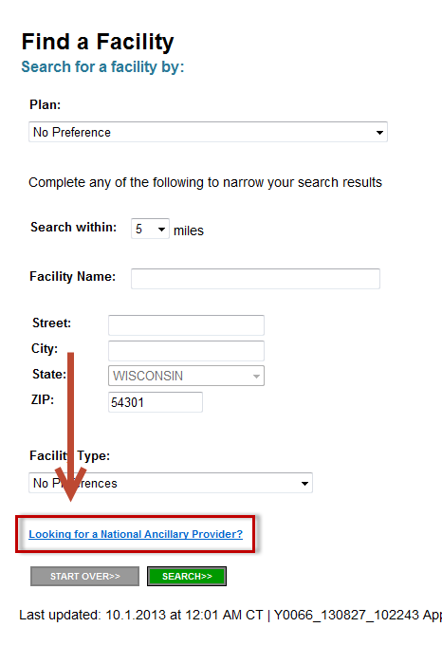

- This will return a list of national ancillary providers. Click on the Download Printer Friendly PDF link to get a PDF version of the list.

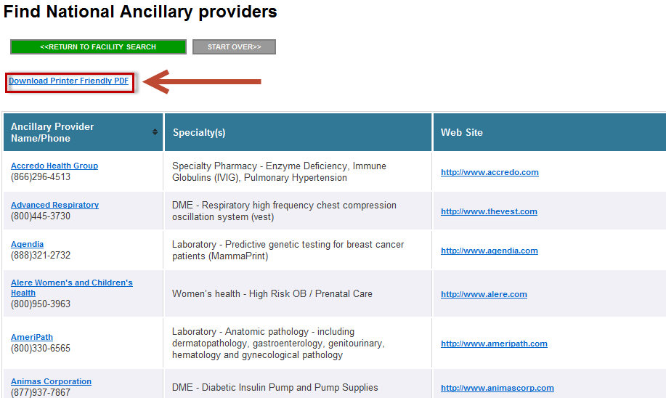
Return to Table of Contents

Vision
Each Welcome Kit contains a provider directory that lists in-network providers for the plan. In most cases, a member will see an optometrist for a routine eye exam. Members will find those UHC Vision providers in the “vision” section of the provider directory.

In addition, a member can register on www.myuhcvision.com. If the member should try a quick provider search on the www.myuhcvision.com, they may, if they are not logged into their account, see providers that do not service just Medicare Advantage plans but rather other UnitedHealthcare plans. Costco is an example. While Costco providers may perform an exam for a member, UnitedHealthcare will not cover eyewear purchased at Costco.

For plans that offer vision benefits, but are not provided through a vendor like UHC Vision, members can access routine vision exams from network optometrists/ophthalmologists indicated in the “specialist” section of the provider directory. If the member has a routine vision eyewear benefit that is not provided through a vendor like UHC Vision, then the benefit is available from any provider (fee-for-service) and members can submit the bill to UnitedHealthcare for payment.

To perform a quick provider search, follow the instructions below:

- Go to www.myuhcvision.com and scroll to the bottom of the page. In the lower, left-hand corner, you will see the Provider Quick Search.

- Enter a valid zip code or address/city/state combination and click the Search button

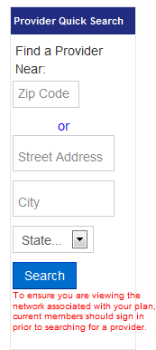

- Up to 100 results matching the search criteria will be returned
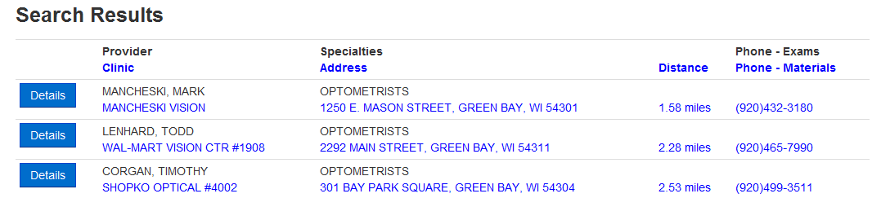

Return to Table of Contents

Dental
- Click on the Look up providers here link located under the Dental Providers section
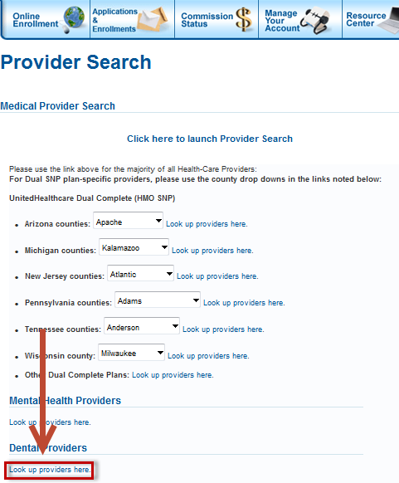

- Click on the Find a Dentist link on the right hand navigation bar
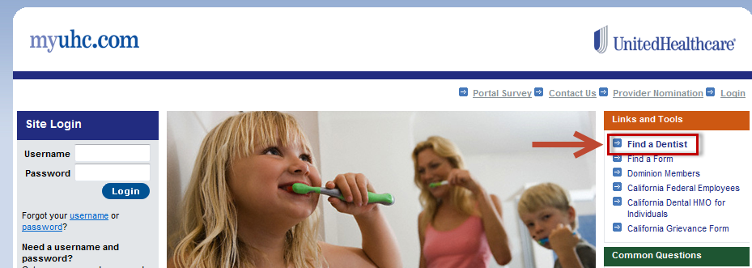
- From the DENTIST SEARCH screen, click on the MEDICARE AND RETIREMENT PLAN NATIONAL NETWORK link
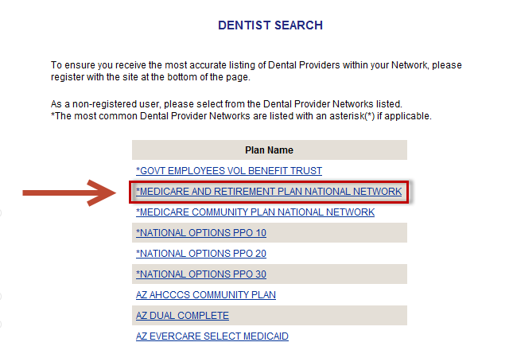

- Complete the appropriate search criteria fields and click Submit
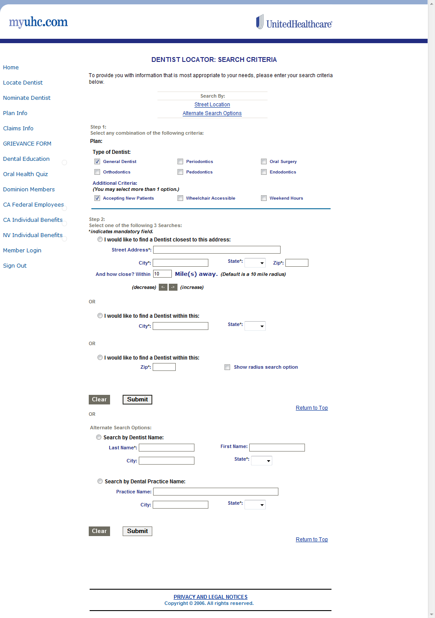
Return to Table of Contents

Hearing
Click on the Hearing Aid Plan Information link located on the Training Tools & Resources section of the Learning Center tab
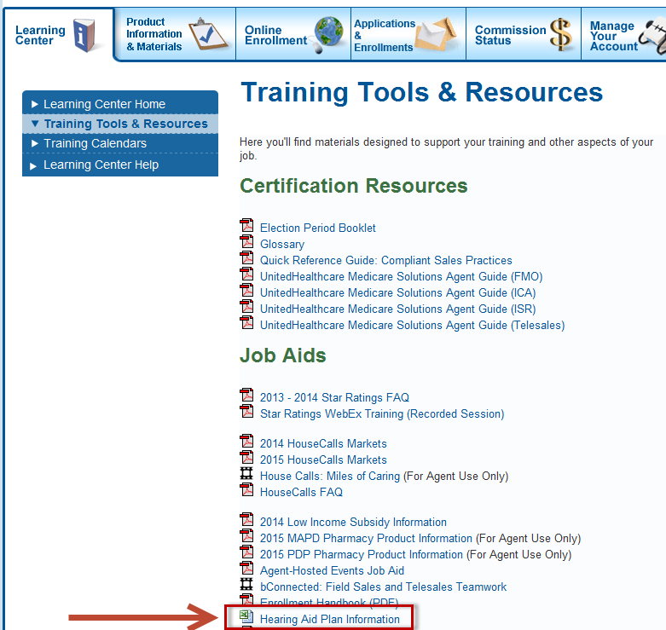
- From the Quick Links section, choose the corresponding plan year

Complete the following steps to return plan-specific information:
- Enter the state and plan number

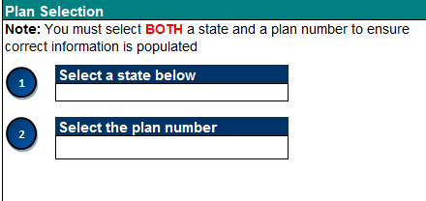
- Once the plan selection information has been entered, the tables will populate with information specific to that plan
  - Use the Hearing Aid Contact Information section to determine the specific phone number and/or website required to look up a participating provider
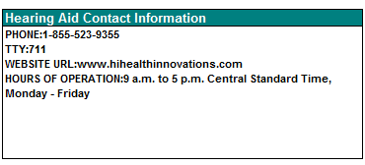

Return to Table of Contents

Behavioral Health
- Click on the Look up providers here link located underneath the Mental Health Providers section

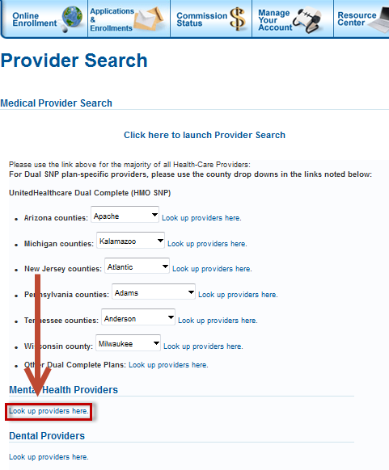

- Click on the Search for Clinician link from the right hand navigation bar
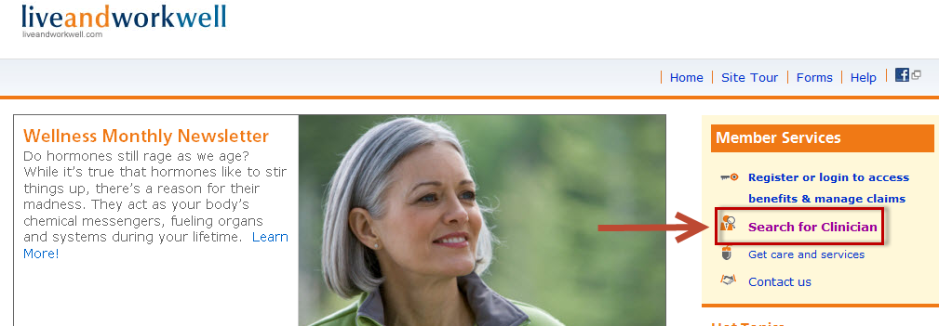
- Click on the Click here to use our free behavioral health clinician search tool link

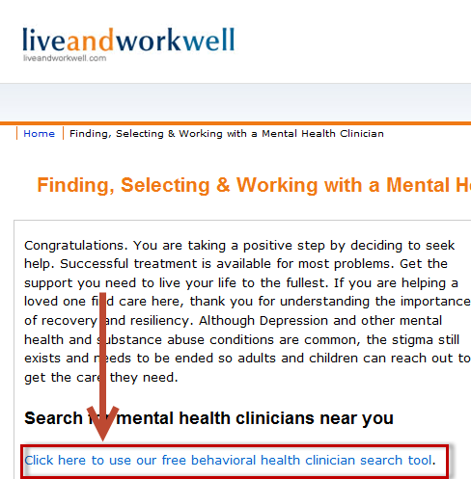

Return to Table of Contents

- Select the appropriate radio button based on the plan type
  - Medicare & Medicaid Clinician only – DSNP Plans
  - Medicare Clinician only – All other plans
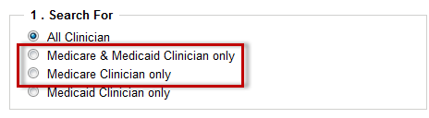

- Fill out the remaining search criteria and click Search for a list of records that match the search criteria

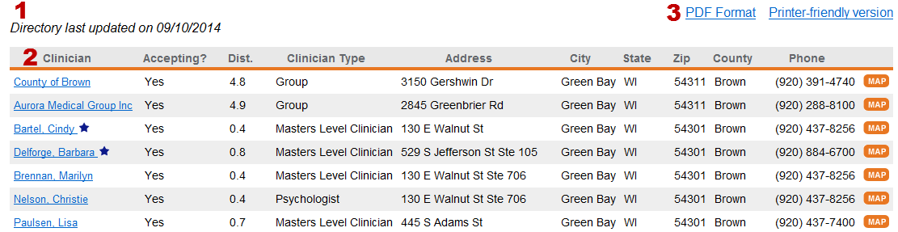
1 | Indicates when the directory was last updated
2 | Provides additional detail about each clinician
3 | Gives the option to view the results in a PDF or a Printer-friendly webpage

Return to Table of Contents

